Post-Perception and Post-Truth Art: Convergences and Divergences

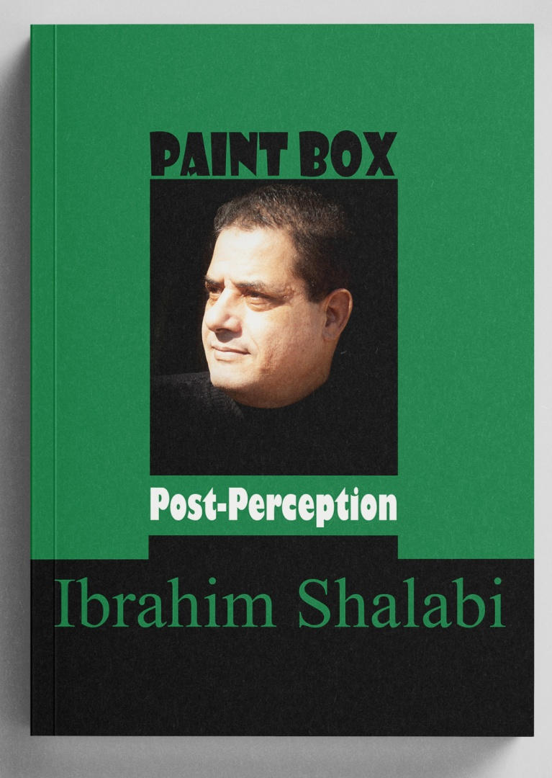
Prepared by: Ibrahim Shalabi Conceptual Artist and Founder of the "Post-Perception" Movement

Introduction: The Post-Truth Era and Artistic Challenges
In 2016, the Oxford Dictionary selected "Post-Truth" as its Word of the Year, defining it as "circumstances in which objective facts are less influential in shaping public opinion than appeals to emotion and personal belief." This profound shift in our relationship with truth inevitably impacted the arts, giving rise to "Post-Truth Art." This movement grapples with the collapse of trust in official narratives and responds to the era of fake news and media manipulation.
In contrast, the "Post-Perception" movement offers a distinct approach. While both disrupt certainty, the former focuses on destabilizing trust in content and information, whereas the latter focuses on destabilizing the mechanisms of perception themselves. This study provides an in-depth comparison between the two, revealing their points of intersection and their unique positions within the landscape of contemporary art.

I. Theoretical Framework: What is Post-Truth Art?

1.1 Characteristics
Post-Truth Art responds to an era where trust in news institutions and objective facts has eroded. Its primary features include:
- Skepticism of Official Narratives: Re-examining historical and media-driven accounts.
- Deception as an Aesthetic Tool: Utilizing fake news and fabricated images as raw artistic material.
- Proximity to Politics and Media: Analyzing and exposing the falsity of media discourse.
- Hybridization of Reality and Fiction: Creating worlds where it is difficult to distinguish fact from fabrication.

1.2 Notable Examples
- Gillian Wearing: In Wearing Gillian (2018), she used over 15 actors and "deepfake" face-swapping technology to create a multifaceted image of identity, questioning who "the self" truly is in an age of effortless digital fabrication.
- Áron Kútvölgyi-Szabó: In Patterns of Counterknowledge, he treated conspiracy theories as a perceptual phenomenon, using layers of tracing paper to obscure or frame information, demonstrating how visual noise disrupts truth.

II. Post-Perception: Redefining the Problem

2.1 Characteristics
Post-Perception is a contemporary artistic-philosophical movement aiming to deconstruct the standardized relationships between the senses and meaning. Its features include:
- Focus on Perceptual Mechanisms: The core question is not "What do we see?" but "How do we see?"
- Perceptual Shock: Using sensory contradiction to shake the "automaticity" of perception.
- Cognitive Participation: The recipient is a partner in constructing meaning, not a passive consumer.
- Perceptual Immunity: Building cognitive defenses against deception.

III. Core Comparison Table
Feature | Post-Truth Art | Post-Perception
Central Question | How do we expose false narratives? | How do we protect perception from deception?
Subject of Critique | Content, Information, Narratives. | Perceptual mechanisms, Senses, Language.
Primary Tool | Fabrication, Irony, Parody. | Perceptual Paradox, Sensory Shock.
Technology | A medium for deception. | A means to reveal perceptual fragility.
The Recipient | A skeptic of information. | A laboratory for a perceptual hypothesis.
Final Goal | Exposing media/political falsity. | Building Perceptual Immunity.
Philosophical Root | Media Criticism, Post-Structuralism. | Phenomenology, Semiotics, Arabic Philosophy.
التصدير إلى "جداول بيانات Google"

IV. Convergences: Points of Intersection
- Destabilizing Certainty: Both movements shake the foundations of what we consider "truth." Post-Truth shakes the narrative; Post-Perception shakes the senses.
- Technological Utility: Both use new technologies (Deepfakes, AI, AR) as essential tools—one to create alternative realities, the other to create perceptual disturbances.
- Questioning Authority: Both challenge the entities that produce meaning, whether they are political institutions (Post-Truth) or the authority of language and algorithms (Post-Perception).

V. Divergences: Fundamental Differences

5.1 Content vs. Mechanism
Post-Truth art critiques the message (the news, the story), whereas Post-Perception critiques the hardware (the eyes, the ears, the cognitive processing).

5.2 Technology: End vs. Means
In Post-Truth Art, technology is often the essence of the work (e.g., a deepfake video). In Post-Perception, technology is merely a means. A perceptual shock can be achieved with simple physical objects like an apple, a cage, or a wooden chair (e.g., The Throne), ensuring the idea remains superior to the tool.

5.3 The Role of the Recipient
In Post-Truth art, the interaction is primarily intellectual—discovering a lie. In Post-Perception, the interaction is physical and existential—the recipient must make a sensory decision.

VI. From Content Critique to Perceptual Fortification
The transition from Post-Truth Art to Post-Perception represents a natural evolution:
- Stage 1 (Post-Truth): We discover that the media lies and images are faked. we demand objective facts.
- Stage 2 (Post-Perception): We discover a deeper problem. Even if sources are reliable, our senses are hackable. Perception is not a transparent window to the world; it is a complex, penetrable construct.

Conclusion: From Exposing Lies to Protecting Consciousness
Post-Truth art frees us from the external lie—the falsified narrative. Post-Perception frees us from the internal illusion—the fragility of our own biological and linguistic filters.
Together, they form a comprehensive project for the protection of human consciousness. As the Post-Perception Manifesto states:
"In a world of accelerating simulation and eroding truth, art becomes a laboratory for consciousness and a perceptual immunity that reconnects humanity with meaning." The true challenge is not just exposing the lie, but building the immunity to ensure we are never deceived by our own perceptions again.

مراجع

- شلبي، إبراهيم. علبة ألوان: ما بعد الإدراك. 2026.
- Oxford Dictionary. "Post-Truth" Word of the Year 2016.
- Masaryk University. K otázkam percepcie a interpretácie umenia programovateľných médií. 2017 .
- Kútvölgyi-Szabó, Áron.Patterns of Counterknowledge. Brno House of Arts, 2018 .
- Cultured MagazineArtists Glenn Ligon and Gillian Wearing on Making Paintings in a Post-Truth World*. 2023 .

